FACULTY OF TECHNOLOGY

Agriculture Group

Sanaz Haghighi
Miglio Krajewski
Nima Marchin
Luanna Draskoczy

Oulu Hydrogen Challenge

University of Oulu

March 2026

TABLE OF CONTENTS
1 Introduction 3
2 Methodology & Simulation Architecture 3
2.1 The Core: Electrolyzer Unit 4
2.2 Mass Flow Systems (Hydrogen & Oxygen) 4
2.3 Thermal Recovery & Distribution 5
3 MODEL PARAMETERS & DATA LOGIC 5
3.1 Wind Farm (P_electrolyzer) 6
3.2 Fish Farm Design 6
3.3 Parameters/Stocks/Flows 7
3.4 Key Equations 9
3.4.1 Variables 10
3.4.2 Hydrogen Production Rate 10
3.4.3 Oxygen Production Rate 10
3.4.4 Fish Tank Oxygen Concentration 11
3.4.5 Heat Production Rate 11
3.4.6 Greenhouse Temperature 11
3.4.7 Fish Tank Temperature 11
4 Bibliography 12

Introduction
The Superfarm project represents a transition from traditional linear industrial models to a circular "Waste-to-Value" framework. The project’s core philosophy, "Using Waste to Grow Fish and Plants," addresses the inherent inefficiencies in green hydrogen production, where byproduct oxygen and thermal energy are often treated as secondary waste streams rather than valuable resources.
This simulation acts as a Digital Twin, providing a high-fidelity environment to validate the technical and economic viability of integrating electrolysis with localized agriculture. The primary objectives of the model are:
- System Sustainability & Stability: To evaluate if the intermittent and fluctuating byproduct streams (oxygen and heat) can maintain a stable biological environment for a fish tank and a vertical greenhouse module.
- Engineering Design & Component Sizing: To assist in the precise sizing of physical infrastructure, such as buffer capacities and tank volumes, based on dynamic mass and energy flow rates.
- Economic & Financial Grounding: To generate empirical data necessary for performing accurate Return on Investment (ROI) and operational cost calculations.
By focusing on the dynamic balance of these flows within a symbiotic module, this simulation ensures technical reliability before moving to physical implementation.

Methodology & Simulation Architecture
The simulation is constructed using a System Dynamics (SD) framework, which allows for the modeling of complex interactions through stocks, flows, and feedback loops. The architecture is designed to replicate the physical "Industrial Symbiosis" by connecting three primary layers (Hydrogen, Oxygen, and Thermal Energy) of energy and mass transfer.
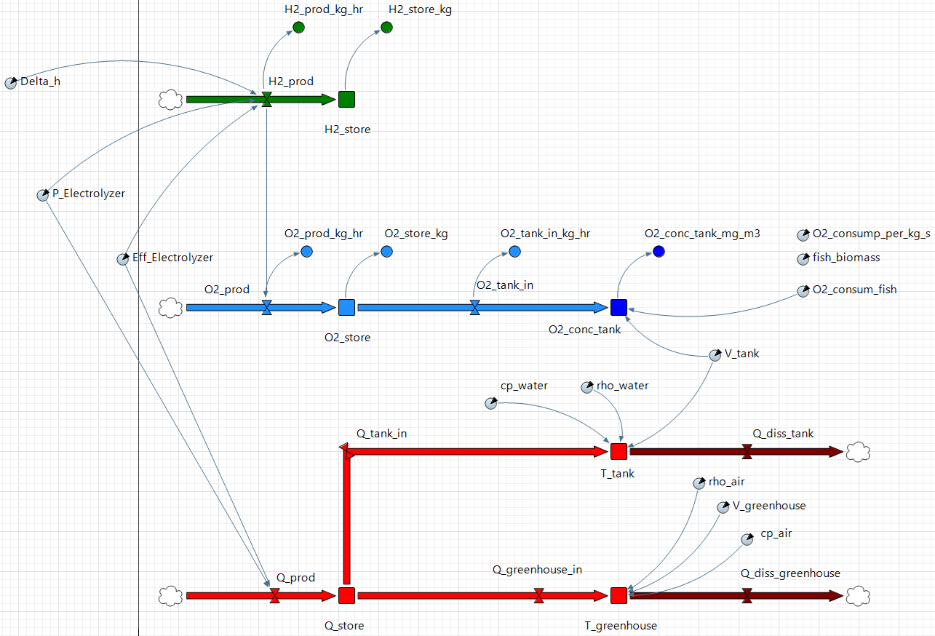
Figure 1: System Dynamics Architecture of the Superfarm Digital Twin in AnyLogic.
To ensure a high-fidelity representation of the Superfarm system, the model employs a multilayered modular design:

The Core: Electrolyzer Unit
The electrolyzer acts as the primary source node in the simulation. It takes electrical power input (P_Electrolyzer) and, based on the reaction enthalpy (Delta_h) and efficiency (Eff_Electrolyzer), generates three simultaneous outputs: Hydrogen gas, Oxygen gas, and Dissipated Heat (Q_prod).

Mass Flow Systems (Hydrogen & Oxygen)
The model treats the byproduct gas as a critical resource for biological life support:
- Hydrogen Circuit: Captures the main product flow (H2_prod) into a storage stock (H2_store) for industrial use.
- Oxygen Symbiosis: Instead of venting, the oxygen produced (O2_prod) accumulated in the buffer (O2_store). It is then regulated through a flow (O2_tank_in) to maintain the oxygen concentration in the fish tank (O2_conc_tank) according to the biological consumption of the fish.
- Biological Respiration: The model accounts for a 200,000 kg fish biomass, where oxygen consumption (O2_consum_fish) is dynamically calculated based on specific respiration rates per kilogram.

Thermal Recovery & Distribution
This model features a dual-sink thermal distribution system to maximize energy efficiency:
- Thermal Storage: The dissipated heat (Q_prod) is captured and stored in a central energy storage unit (Q_store).
- Aquaculture Heating: Energy is routed via a heat transfer flow (Q_tank_in) to regulate the fish tank temperature (T_tank), considering water properties such as density (rho_water) and specific heat capacity (cp_water).
- Greenhouse Heating: Simultaneously, heat is transferred through a heat flow (Q_greenhouse_in) to the vertical farm module to maintain the greenhouse temperature (T_greenhouse).
- Dissipation Analysis: The model accounts for environmental heat loss through two heat flows (Q_diss_tank and Q_diss_greenhouse) to evaluate the system's thermal efficiency.

MODEL PARAMETERS & DATA LOGIC
The model is of a hypothetical hydrogen plant with PEM electrolyzers. The power for plant operation comes from an islanded wind farm with a similar capacity. It is assumed that the heat output of the electrolyzer is very large compared with the oxygen output. Therefore, the fish farm is sized first, based on the oxygen output, and the greenhouse is sized based on the heat remaining after the fish farm demand has been calculated.

Wind Farm (P_electrolyzer)
The power capacity of the wind farm for the simulation was scaled from proposed projects in Norway [1]. The capacity factor was taken from the same source and the power output over 24 hours was scaled to data from Fingrid [2]. Although Fingrid data is for all of Finland, data for specific wind farms is not easily found. Therefore, the profile is the best approximation for our project. The power output was scaled as follows:
- Hourly Averaging: The raw 3-minute real-time production data from Fingrid (March 6th-7th) was aggregated into hourly mean values to provide a consistent daily profile.
- Normalization: Each hourly mean was divided by the total national wind capacity ($9,394 MW$) to derive the dimensionless 'k-factor' representing the regional wind volatility.
- Calibration: Since the raw mean was $38.5 \%$, a multiplier of $1.16739$ was applied to scale the daily average to our target $45 \%$ Capacity Factor.
- Energy Scaling: The calibrated factors were multiplied by the farm capacity ($2.9 MW$) to generate the final hourly energy output (MWh).
The resulting profile ensures the total energy output over 24 hours is exactly $2.9 MW*0.45*24 hr$, with no hourly peak exceeding the $2.9 MW$.

Fish Farm Design
- The electrolyzer plant has a capacity of $2.5 MW$; This assumption is made, as the model is vaguely based on the $2.5 MW$ Berlevag project [3], [4].
- The electrolyzer plant is PEM, with an efficiency of $70 \%$.
- The wind farm has a capacity of $2.9 MW$; scaled from the $175 MW$ electrolyzer project and assuming that the entire power output is used for hydrogen production [1].
- The wind farm has a capacity factor of $45 \%$ [1] (The lower capacity factor from the projects in the source is selected for safety margin).
- Fish are assumed to consume $350 mg O_{2}/kg/hr$ [5], variable oxygen consumption based on feeding times is not considered (this value depends on the type of fish).
- The biomass content of the fish farm is considered to be $2.5 \%$ [6].
To calculate the size of the fish tank, the average production of oxygen per hour must be calculated. The first step is to calculate how much energy is available for electrolysis per hour on average:
$$capacityFactor*1hr*capacity*eff=E_{electrolysis}=0.917 MWh/hr=3.29 GJ/hr$$
The energy produced per hour can be divided by the formation enthalpy of one mol of hydrogen and multiplied by a factor of 0.5 to give the amount of oxygen produced per hour in mol:
$$\frac{E_{electrolysis}}{∆H}*0.5={O_{2}}_{prod}=5754.97 mol/hr=184.16 kg/hr$$
The amount of oxygen produced per hour can be divided by the amount of oxygen required by the fish per kilogram per hour to give the amount of fish in kilograms:
$$\frac{{O_{2}}_{prod}}{{O_{2}}_{consum}}=m_{fish}=526 171.43 kg=526.17 t$$
This value can be used to calculate the total volume of the fish tank using the biomass content:
$$\frac{m_{fish}}{biomassContent}*100=m_{tank}=V_{tank}=21 046.86 m^{3}$$

Parameters/Stocks/Flows
Parameters | Value/Unit | Description
P_Electrolyzer | variable | Power output of a $2.9 MW$ wind farm for a $2.5 MW$ industrial pilot scale PEM electrolyzer plant. [7]
Eff_Electrolyzer | $$0.7$$ | Mid-range efficiency of alkaline or PEM electrolyzers (considered constant). [8]
Delta_h | $$285 840 \frac{J}{mol}$$ | Formation enthalpy (energy required to form $1 mol$ of $H_{2}$ from $H_{2}O$). [9]
V_tank | $$21 046.86 m^{3}$$ | Calculated from Oxygen production, oxygen consumption of fish and space required for resulting amount of fish.
V_greenhouse | $$1500 m^{3}$$ | Volume of the greenhouse
cp_water | $$4180 \frac{J}{kg.K}$$ | The specific heat capacity of water.
cp_air | $$1005 \frac{J}{kg.K}$$ | The specific heat capacity of air.
O2_consum_fish | $$1.59\frac{mol}{s}$$ | See “Fish Farm Design” for calculation; result converted to mol to match units in simulation.
rho_air | $$1.225\frac{kg}{m^{3}}$$ | Density of air
rho_water | $$1000\frac{kg}{m^{3}}$$ | Density of water

Stock | Unit | Description
H2_store | $$mol$$ | Produced hydrogen
O2_conc_tank | $$\frac{mol}{m^{3}}$$ | Concentration of oxygen in fish tank
O2_store | $$mol$$ | Oxygen in buffer
Q_store | $$J$$ | Heat in heat storage
T_tank | $$K$$ | Temperature of the fish tank
T_greenhouse | $$K$$ | Temperature of the greenhouse

Flow | Unit | Description
H2_prod | $$\frac{mol}{s}$$ | Hydrogen production rate
O2_prod | $$\frac{mol}{s}$$ | Oxygen production rate
O2_tank_in | $$\frac{mol}{s}$$ | Oxygen transfer rate from buffer to fish tank
Q_diss_greenhouse | $$\frac{J}{s}$$ | A dummy value representing heat loss from the greenhouse
Q_diss_tank | $$\frac{J}{s}$$ | A dummy value representing heat loss from the fish tank
Q_greenhouse_in | $$\frac{J}{s}$$ | A dummy value representing the heat flow to the greenhouse
Q_tank_in | $$\frac{J}{s}$$ | A dummy value representing the flow of heat to the fish tank
Q_prod | $$\frac{J}{s}$$ | Heat production rate

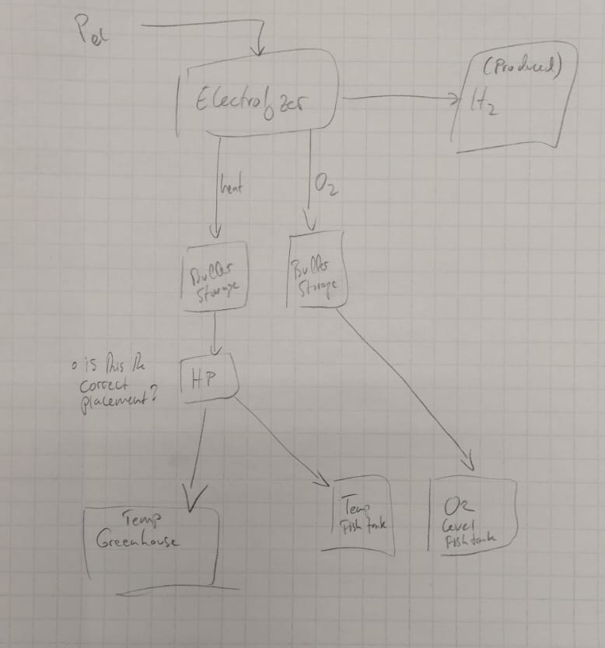
This obviously needs to be digitalized, its just preliminary. It’s the original idea.

Key Equations
Each equation is represented in a part of the model. The variable names are not the same as in the model, to make the equations more easily recognizable at a glance. The equation is described shortly and the section of the model where it can be found is named. The variables for the equations below are listed under Variables.

Variables
$$H_{2, prod}$$
$$P_{Electrolyzer}$$
$${Eff}_{Electrolyzer}$$
$${∆H}_{H_{2}}$$
$${Rate}_{O_{2}}$$
$${Rate}_{H_{2}}$$
$${Rate}_{O_{2}, in}$$
$$Rate_{O_{2}, consumed}$$
$$V_{tank}$$
$$Q_{ prod}$$
$$Q_{in}$$
$$Q_{diss}$$
$$m_{air,greenhouse}$$
$$m_{water,tank}$$
$$C_{P_{water}}$$
$$C_{P_{air}}$$

Hydrogen Production Rate
Description: calculates hydrogen production rate ($mol/s$) from electrical power input ($kW$).
$$H_{2, prod}=\frac{P_{Electrolyzer}×{Eff}_{Electrolyzer}}{{∆H}_{H_{2}}}$$

Oxygen Production Rate
Description: Based on the molar ratio of $H_{2}$ to $O_{2}$ in $H_{2}O$
$${Rate}_{O_{2}}={Rate}_{H_{2}}×0.5$$

Fish Tank Oxygen Concentration
Description: concentration of oxygen in the fish tank water as an integral of:
$$\frac{{Rate}_{O_{2}, in}-Rate_{O_{2}, consumed}}{V_{tank}}$$

Heat Production Rate
Description: Based on the efficiency of the electrolyzer. Assumption is that all the electrical energy not used for hydrolysis becomes usable waste heat.
$$Q_{ prod}=P_{Electrolyzer}×{(1-Eff}_{Electrolyzer})$$

Greenhouse Temperature
Description: Calculates temperature in the greenhouse as an integral of:
$$\frac{Q_{in}-Q_{diss}}{m_{air,greenhouse}*C_{p_{air}}}$$
This function of the simulation is incomplete, as there are no temperature gradients determining the heat flow.

Fish Tank Temperature
Calculates temperature in the fish tank as an integral of:
$$\frac{Q_{in}-Q_{diss}}{m_{water,tank}*C_{P_{water}} }$$
This function of the simulation is incomplete, as there are no temperature gradients determining the heat flow.

Bibliography
[1] PowerPoint Presentation’. Accessed: Mar. 06, 2026. [Online]. Available: https://www.hydrogen.no/files/documents/medlemsmoter/h2carrier.pdf
[2] Download datasets. Accessed: Mar. 09, 2026. [Online]. Available: https://data.fingrid.fi/en/data?datasets=181
[3] NIB lends to Varanger Kraft´s hydrogen and power grid projects’, Nordic Investment Bank. Accessed: Mar. 08, 2026. [Online]. Available: https://www.nib.int/news/nib-lends-to-varanger-krafts-hydrogen-and-power-grid-projects/
[4] Hydrogen-Aeolic Energy with Optimised eLectrolysers Upstream of Substation | H2020’, CORDIS | European Commission. Accessed: Mar. 08, 2026. [Online]. Available: https://cordis.europa.eu/project/id/779469/reporting
[5] Dissolved oxygen requirements in aquatic animal respiration - Responsible Seafood Advocate’, Global Seafood Alliance. Accessed: Mar. 06, 2026. [Online]. Available: https://www.globalseafood.org/advocate/dissolved-oxygen-requirements-in-aquatic-animal-respiration/
[6] Fish density on our farms’. Accessed: Mar. 07, 2026. [Online]. Available: https://griegseafood.com/our-impact-fish-density-on-our-farms
[7] ‘Haeolus – Hydrogen-Aeolic Energy with Optimised eLectrolysers Upstream of Substation’. Accessed: Mar. 06, 2026. [Online]. Available: https://haeolus.eu/
[8] D. Virah-Sawmy, F. J. Beck, and B. Sturmberg, ‘Ignore variability, overestimate hydrogen production – Quantifying the effects of electrolyzer efficiency curves on hydrogen production from renewable energy sources’, Int. J. Hydrog. Energy, vol. 72, pp. 49–59, Jun. 2024, doi: 10.1016/j.ijhydene.2024.05.360.
[9] A. Godula-Jopek, Hydrogen Production by Electrolysis. 2015.

